

**Assignment**

**Assignment on SRS (Software Requirement Specification)**

**Course Code: CSE–404**

**Section: 1**

**Course Title: Software Engineering**

Submitted To

Mr. Md Anowarul Abedin

Lecturer, Department of CSE – ULAB

Submitted By

Nahid Reza - 143014013

Nadia Rahman - 143014026

Mrinmoyee Dey Amin - 143014037

Afsana Shikder Samia - 143014047

Md. Asifuzzaman Jishan - 143014010

Mahmud Hossain - 142014041

Taraq Rahman - 141014020

Md. Atik-Uz-Zaman - 143014054

Submission Date: September 3, 2018

1. **INTRODUCTION**
   1. **PURPOSE**

Infinity software company limited sells house ware products and designs. The company offers bath accessories, bath storage items, bath and vanity organizers, shower caddies, shower suction organizers, constant tension shower curtain rods, shower curtains, and rugs. It also offers closet organizers, hooks and racks, and baskets and containers for home storage applications. It offers its products through retailers in the Bangladesh and internationally. The company was founded in 2018.

* 1. **DOCUMENT CONVENTIONS**

This document uses the following conventions-

|  |  |
| --- | --- |
| DB | Database |
| HTML | Hypertext markup language |
| CSS | Cascading style sheets |

* 1. **INTENDED AUDIENCE AND READING SUGGESTIONS**

This project is a prototype and it is restricted within the college premises. This has been implemented under the guidance of highly educated designers. This project is useful for lower people to modern people and as well as to the new designers.

* 1. **PROJECT SCOPE**

The purpose of this project is to create a convenient and easy-to-use application for customers, trying to buy or sell products. The system is based on a relational database with its customers, managers and admins and reservation functions. We will have a database server supporting hundreds of major cities around the world. Above all, we hope to provide a comfortable user experience along with the best pricing available.

* 1. **REFERENCES**
* <https://krazytech.com/projects>
* Fundamentals of database systems

**2. OVERALL DESCRIPTION**

**2.1 PRODUCT PERSPECTIVE**

A database system stores the following information-

* **Product details:**   
  It includes the fascinating designs and well-furnished decorations, mostly all the products are different from each other and definitely it will mesmerize you all.
* **Customer description:**   
  It includes customer code, name, address and phone number. This information may be used for keeping the records of the customer for any emergency or for any other kind of information.
* **Order description:**   
  It includes customer details, code number, date of booking, date of delivery.

**2.2 PRODUCT FEATURES**

The major features of **Infinity Software Company Limited is shown in**

1. Class diagram
2. Activity diagram
3. Use case diagram

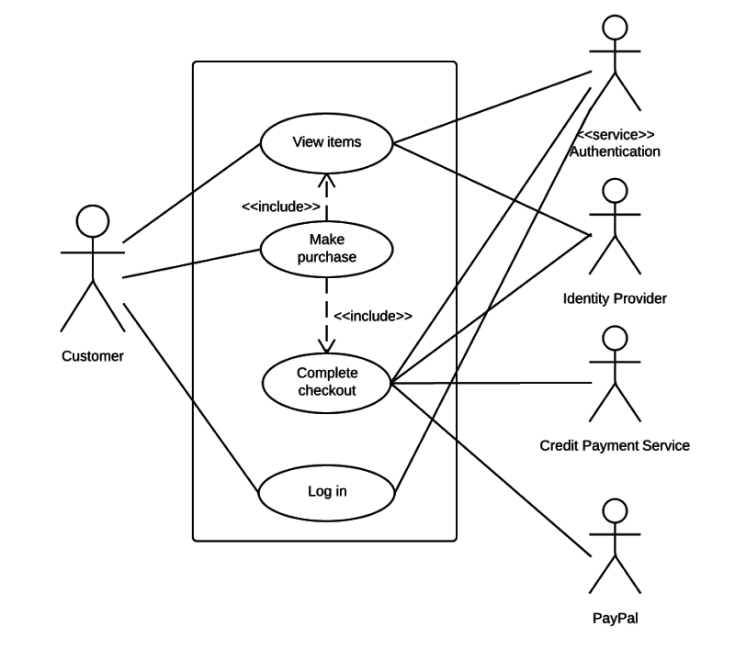

**Fig1: Diagram of Use case**

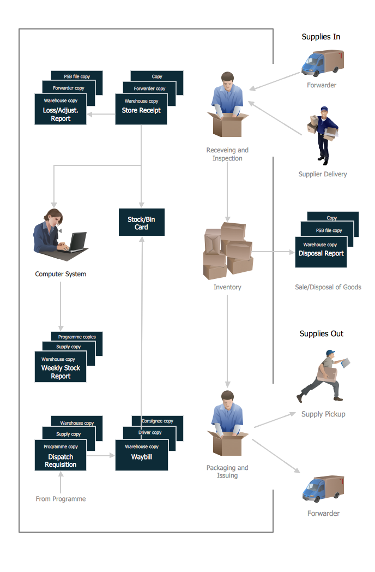

**Fig2: Diagram of Activity Diagram**

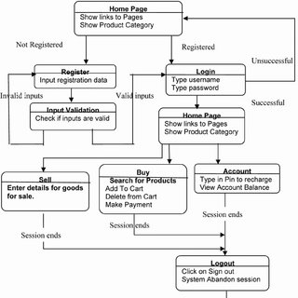

**Fig3: Class diagram**

**2.3 USER CLASS and CHARACTERISTICS**

Users of the system should be able to retrieve information. The system will support two types of user privileges, Customer, and Employee. Customers will have access to customer functions, and the employees will have access to both customer and company. The customer should be able to do the following functions:

• Make an order   
 • Choose as per their budget  
 • Can make their own design if they want  
 • Flexible time/date  
 • Confirmation

* Cancel an existing order
* View his/her itinerary

The Employee should have following management functionalities

* Confirm their order
* Take payment through their demand
* Calculate the amount
* Make sure the product is supplied

**2.4 OPERATING ENVIRONMENT**

Operating environment for system is as listed below-

* client/server system
* Operating system: Windows.
* Database: MySQL
* Platform: Back end: Laravel

Front end: HTML, CSS

**2.5 DESIGN and IMPLEMENTATION CONSTRAINTS**

1. The global schema, fragmentation schema, and allocation schema.
2. SQL commands for above queries/applications
3. How the response for application 1 and 2 will be generated. Assuming these are global queries. Explain how various fragments will be combined to do so.
4. Implement the database at least using a centralized database management system.

**3. SYSTEM FEATURES**

* 1. **DESCRIPTION and PRIORITY**

The system maintains information on products, personal preferences, prices, and bookings of course. This project has a high priority because it is very difficult to travel across countries without prior reservations.

**4. EXTERNAL INTERFACE REQUIREMENTS**

**4.1 USER INTERFACES**

* Front-end: HTML, CSS
* Back-end: Laravel
* Database: MySQL

**4.2 HARDWARE INTERFACES**

* Windows.
* A browser which supports HTML, CSS and Laravel.